

Assignment -01(Setup Of Environment)

**Course code: CSE 303**

**Course name: Advanced Statistics For Data Science**

**Section: 07 (Fall 24)**

**Submitted by:**

|  |  |
| --- | --- |
| Name | ID |
| Farhan Ibtesham Joy | 2022-3-60-150 |

**Submitted to:**

**Ms. Puja Chakraborty**

**Lecturer**

Department of Computer Science & Engineering

**East West University**



1. **Describe what is python script, python module and library?**

**Python Script:** A python script refers to the plain code that concieves the python script to be executed. It generally contains .py form in the end of its’ file

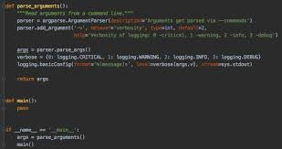

**Python Module**:A Python file (or collection of files) that can be imported and reused in other Python programs. Modules encapsulate reusable code like functions and classes.

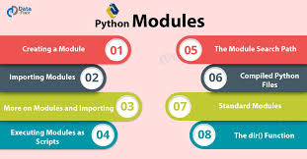

**Library**: A collection of modules packaged together to provide specific functionality. Examples include NumPy for numerical computing and Requests for HTTP requests.





1. **Point out the difference and use of .py and . ipynb files.**

**.py Files**: Standard Python scripts containing code in plain text. They are run linearly and are typically used in traditional software development.

**.ipynb Files:** Jupyter Notebook files that include Python code, outputs, visualizations, and markdown documentation. They are ideal for exploratory data analysis and interactive computing.

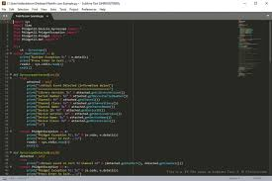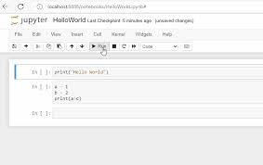

**.Ipnyb Files .Py files**

1. **What is VsCode and conda?**

**VS Code (Visual Studio Code)**: A lightweight and extensible code editor developed by Microsoft. It supports multiple programming languages and provides extensions for debugging, linting, and version control.

**Conda**: A package and environment manager for Python and other programming languages. It simplifies the installation of libraries and creation of isolated environments.

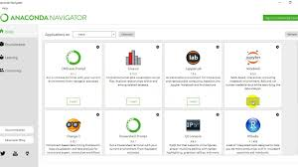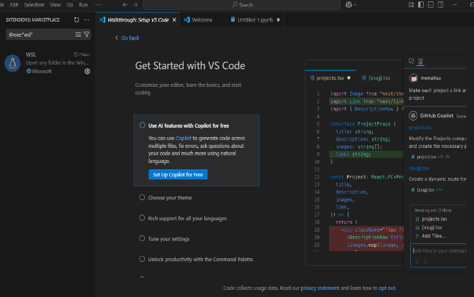

**Vs Code Conda Environmet**

1. **What is a python environment? How to create multiple python environments? How to**

**activate a particular environment with CLI (Command Line Interface)?**



**Desinition:** Python environment is an isolated workspace that contains its own Python interpreter and dependencies.

**Conda Environment:** To create a conda environment, we like: **conda create -n env_name python=version**

**VS code Environment:** python -m venv env_name

We write both of this in terminal, then our environment is created.

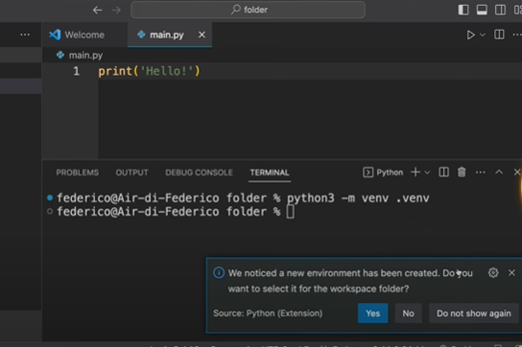

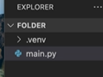

**5.How to integrate conda with VS Code?**

* Install python Extension in VS CODE
* Set the python interpreter
* Choose Conda Environment

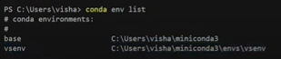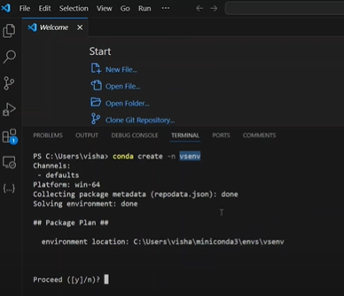

**6 What is git?**

Git is a version control system that tracks changes in code, enabling collaboration and maintaining the history of a project. It is widely used in software development.

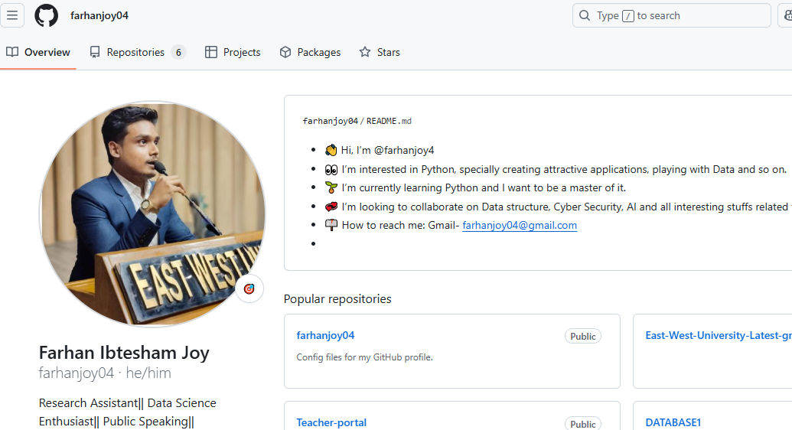

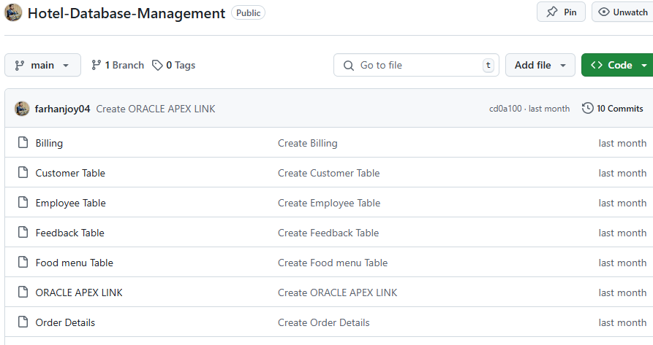

**7,8 Installing all libraries necessary libraries:**

**Installing Pandas:**  Open terminl in VS CODE:

Type: pip install pandas

Press Enter

**Installing Numpy:** Open terminl in VS CODE:

Type: pip install Numpy

Press Enter

**Installing Malplotlib:** Open terminl in VS CODE:

Type: pip install matplotlib

Press Enter

**NOTE:** If sometimes it makes problem, apply pip3 instead of Pip. 3 represents the version of pyhton.

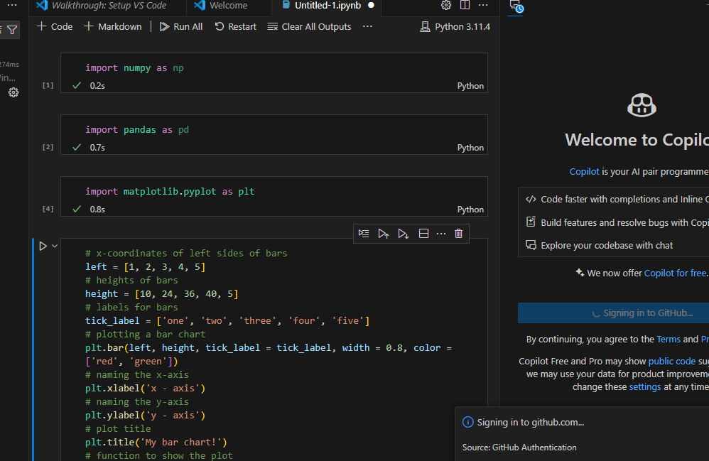

**9. Creating Repo:** A repository, where project files and their version history are stored.

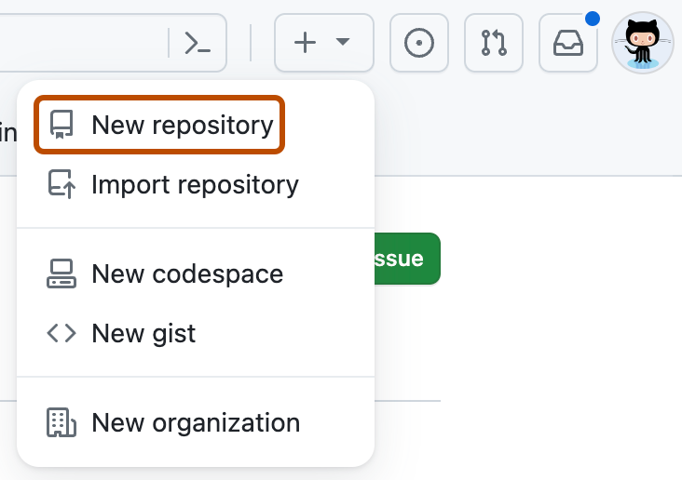

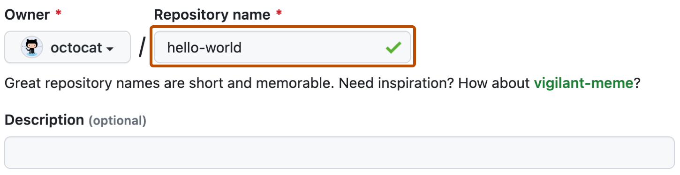

**Stage**: Adding changes to the staging area using git add.

* First code in the file**.**
* Open Terminal
* Write “git add index. (file type eg:- .py/.html/. c)
* “git status” – to viw the status of git version

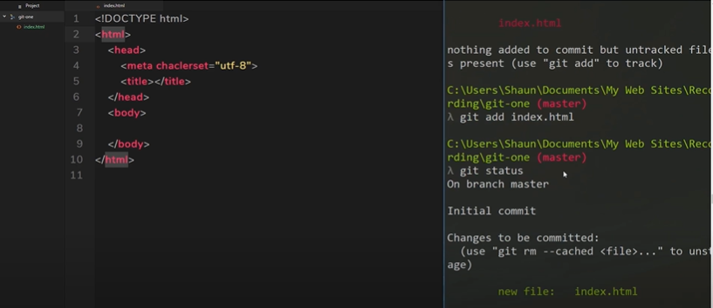



**Commit**: Saving staged changes to the repository with a message describing the update using git commit.

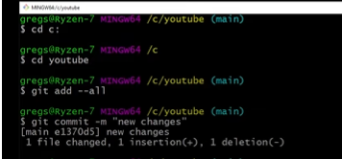

**Push**: Uploading committed changes to a remote repository using git push.

• **Pull**: Downloading changes from a remote repository using git pull.

• **Merge**: Combining changes from different branches.

• **Clone**: Creating a local copy of a remote repository using git clone.

• **Branch**: A parallel version of a repository to work on features independently.

• **Fork**: A personal copy of someone else’s repository.

• **Master/Main Branch**: The default branch of a repository, containing stable code.

**10. Write all git codes:**

• git add . – Stage all changes.

• git commit -m "message" – Commit changes.

• git push origin branch_name – Push changes to remote.

• git pull origin branch_name – Pull updates from remote.

• git merge branch_name – Merge branches.

• git clone repo_url – Clone a repository.

• git branch branch_name – Create a new branch.

• git checkout branch_name – Switch to a branch.

**11.** **What is the importance of ReadMe.md and requirements.txt file in a project?**

**Importance Of Readme File:**  Read me file gives a first impression, overview of the project, and a short description on any project. It also shows the gradual file of the particular project the I am working on.

**Requirements.txt :**  It shows the necessary files , dependencies for the project that I must need/ run while doing the projects.

**END**